**Bank Management System **

**PROJECT REPORT**

Submitted by

**L.Manikandan (2101055)**

*in partial fulfillment for the award of the degree*of

**BACHELOR OF ENGINEERING**

**in**

COMPUTER SCIENCE AND ENGINEERING

**P.S.R. ENGINEERING COLLEGE, SIVAKASI – 626140**

(An Autonomous institution, Affiliated to Anna University, Chennai)

# ANNA UNIVERSITY: CHENNAI 600 025

ABSTRACTION

The Bank Management System marks a pivotal stride in automating conventional banking procedures, tackling issues related to account handling, withdrawals, deposits, and comprehensive account management. Developed using the C++ programming language, this system introduces a streamlined and user-friendly interface to enhance the efficiency of banking operations. Notably, the project prioritizes modularity and scalability, underlining its capacity to seamlessly adjust to evolving banking requirements. This report critically analyzes the project's outcomes, recognizing its strengths while also proposing potential enhancements for future refinements. In summary, the Bank Management System represents a significant advancement, symbolizing a transition towards contemporary and efficient banking practices

**ACKNOWLEDGMENTS**

We take this opportunity to all those who helped towards successful completion of this mini project. At the very outset we thank the almighty for his profuse blessings showered on us. We thank our beloved parents whose encouragement and support help us to complete our project successfully.

It is our greatest pleasure to convey our thanks to **Thiru R. Solaisamy, Correspondent** and **Director Er. S. vigneswari Arunkumar B. Tech., PSR engineering college, Sivakasi** for providing required facilities and suitable infrastructure to complete our project.

It is our greatest privilege to convey our thanks to **Dr. J. S. Senthilkumar, M.E., Ph.D., Principal** for continuous support to complete our project without hurdles.

We proud profound gratitude to our beloved Head of the Department **Dr. A. Ramathilagam, M.E., Ph.D., Professor** for providing ample facilities to complete our project successfully.

We also bound to thanks to all Faulty and Non-teaching staff members of The **Department of Computer Science and Engineering** whose support and cooperation also contributed much to complete this project work.

**TABLE OF CONTENT**

|  |  |  |
| --- | --- | --- |
| **S.NO** | **TOPIC** | **PAGE NO** |
| 1 | INTRODUCTION |  |
| 1.1 | BACKGROUND |  |
| 1.2 | OBJECTIVES |  |
| 2 | LITERATURE REVIEW |  |
| 3 | PROJECT OVERVIEW |  |
| 4 | METHODOLOGY |  |
| 4.1 | SYSTEM ARCHITECTURE |  |
| 4.2 | TECHNOLOGIES USED |  |
| 5 | SYSTEM FEATURES |  |
| 5.1 | ADD USER DETAILS |  |
| 5.2. | MODIFY DETAILS |  |
| 5.3 | DISPLAY DETAILS |  |
| 5.4 | DELETE DETAILS |  |
| 6 | IMPLEMENTATION |  |
| 7 | RESULTS AND OUTCOMES |  |
| 7.1 | USER INTERFACE SCREENSHOTS |  |
| 7.2 | PERFORMANCE METRICS |  |
| 8 | CONCLUSION |  |
| 9 | FUTURE ENHANCEMENT |  |
| 10 | ACKNOWLEDGEMENT |  |
| 11 | REFERENCES |  |
| 12 | APPENDIX |  |

1. **Introduction**

The Bank Management System project represents a paradigm shift in the realm of traditional banking practices, ushering in a new era of efficiency and convenience. By offering a holistic solution for fundamental banking processes such as account creation, withdrawal, deposit, and comprehensive account management, the project seeks to address longstanding challenges and bottlenecks in the conventional banking landscape. This initiative is of paramount significance as it not only streamlines complex banking operations but also significantly improves accessibility for both bank administrators and customers. The system's emphasis on user satisfaction is a crucial aspect, ensuring that interactions with the banking system are intuitive, secure, and tailored to meet the diverse needs of account holders. In essence, the Bank Management System project is poised to redefine the way banking services are delivered, promising a seamless and user-centric experience that aligns with the evolving expectations of modern banking clientele.

2.**Literature Review**

The comprehensive literature review illuminates a compelling consensus on the imperative need for automation within the intricate landscape of banking processes. Diverse scholarly sources collectively advocate for technological interventions, acknowledging the escalating intricacies of financial transactions and the expanding clientele base. In synchrony with these research insights, our Bank Management System project emerges as a strategic response to the contemporary requisites of modern banking. Positioned as a progressive solution, the project systematically addresses the limitations inherent in conventional banking practices, offering a paradigm shift towards efficiency and advanced account management. The project's forward-thinking ethos seeks to reconcile the disparities between traditional methodologies and the dynamic demands of today's banking landscape. By embracing technology, it aims to not only optimize operational processes but also ensure that banking services resonate with the swift and tech-savvy expectations of modern users. Our project, therefore, stands as a transformative force within the banking industry, poised to usher in innovation and meet the challenges presented by the digital era head-on, ultimately shaping a more responsive and future-ready banking experience.

3. **Project Overview**

The Bank Management System project streamlines account operations, prioritizing efficiency through automation. It delivers a user-friendly interface catering to both bank administrators and customers. This initiative modernizes banking practices, aligning with contemporary digital expectations for enhanced operational effectiveness. Ultimately, it aims to elevate customer satisfaction within the banking sector.

4. **Methodology**

4.1 Technologies Used

**C++ Programming Language:**

Selected for its object-oriented features and ease of implementation.

**C++ Standard Libraries:**

Utilized for foundational functions, ensuring reliability and portability across different systems.

**Integrated Development Environment (IDE):**

Utilized for coding, debugging, and testing, ensuring a smooth development process.

4.2 System Architecture

The Bank Management System's architecture places a premium on modularity, featuring distinct modules for key functions like account creation, display, withdrawal, and deposit. This strategic design fosters adaptability, allowing the system to scale seamlessly and accommodate changing demands within the banking landscape. By encapsulating specific functionalities into modules, the architecture enhances maintainability and facilitates future enhancements. The emphasis on scalability ensures that the system can efficiently evolve to meet the dynamic and evolving requirements of the banking sector. In summary, the system's architectural approach underscores flexibility, maintainability, and readiness for future advancements.

5. **System Features**

5.1 Create Account:

Efficiently creates new bank accounts, capturing account number, account holder name, and initial balance.

5.2 Display Account Details:

Provides a comprehensive list of all bank accounts, including account number, account holder name, and balance.

5.3 Withdraw Money:

Facilitates account holders in withdrawing money, ensuring validation for valid account numbers and sufficient balances.

5.4 Deposit Money:

Allows account holders to deposit money, validating input amounts for accuracy.

6. **Implementation**

The implementation phase involves coding the project in C++ within the Code::Blocks environment. The development process adheres to the established methodology, focusing on simplicity, efficiency, and user-friendly design.

7. **Results and Outcomes**

7.1 User Interface Screenshots

Screenshots showcase the system's user interface, providing a visual representation of the project's design and usability. These images demonstrate the simplicity and accessibility of the system.

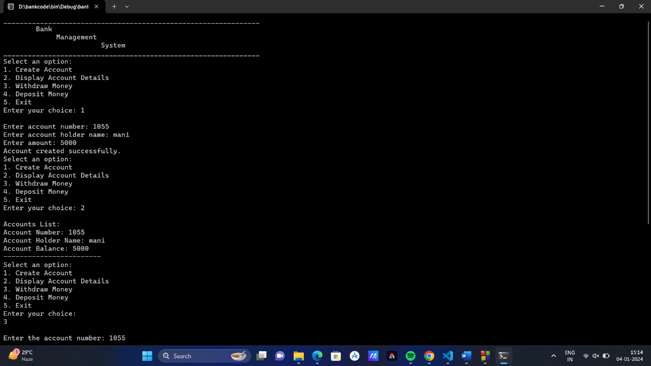

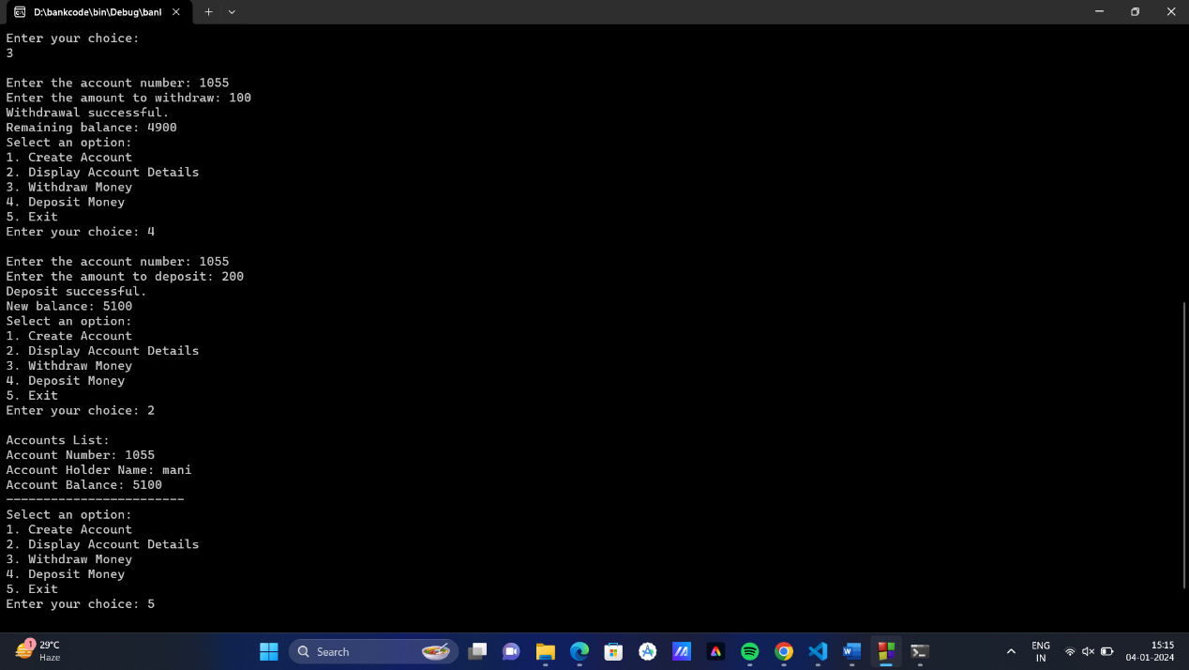

7.2 Performance Metrics

Performance metrics for the Bank Management System encompass critical aspects of operational efficiency. The system's success is gauged by the speed and accuracy of account creation, ensuring a swift and error-free process. Accurate display of account details serves as a key metric, emphasizing the system's ability to provide precise and accessible information to users. Security measures in withdrawal and deposit operations are paramount, with the system evaluated based on its ability to ensure the integrity and confidentiality of financial transactions. Regular monitoring of these metrics is essential to maintaining optimal system functionality, allowing for proactive identification and resolution of any performance issues. The holistic approach to performance evaluation underscores the system's commitment to delivering a seamless and secure banking experience, aligning with industry standards and user expectations. In essence, these metrics serve as benchmarks for the system's effectiveness in meeting operational goals and ensuring a high level of user satisfaction.

8. **Conclusion**

In conclusion, the Bank Management System represents a pivotal transition towards contemporary and streamlined banking practices, ultimately elevating the overall quality of user interactions. This transformative shift underscores the system's commitment to efficiency and innovation within the dynamic landscape of banking operations.

9. **Future Enhancements**

Future enhancements for the Bank Management System are poised to fortify its capabilities and adaptability. This includes advanced security measures like biometric authentication, integration with online banking services for broader accessibility, and incorporation of advanced transaction history features for detailed financial insights. Implementing machine learning for fraud detection, a user-friendly mobile application for on-the-go banking, and exploring blockchain technology for secure transactions are pivotal enhancements. Additionally, AI-powered chatbots for customer support, multi-currency support, and cloud integration for scalability are integral aspects. Ensuring accessibility features for differently-abled users and instituting a robust user feedback mechanism completes the vision for an innovative, secure, and user-centric banking system poised for continuous improvement.

**10. Acknowledgments**

The completion of the Bank Management System project owes a debt of gratitude to our project mentors, whose guidance was pivotal. Special thanks to our peers for fostering a collaborative environment that enriched the development process. The open-source community's contributions significantly enhanced the project's robustness and efficiency. This collective effort underscores the importance of mentorship, peer collaboration, and community support in achieving project success.

11. **References**

* Stroustrup, B. (2013). &quot;Programming: Principles and Practice

Using C++.&quot; Addison-Wesley.

* Code::Blocks. (n.d.). Retrieved from https://www.codeblocks.org/
* GeeksforGeeks. (n.d.). &quot;C++ Programming Language.&quot; Retrieved from https://www.geeksforgeeks.org/c-plus-plus/
* Stack Overflow. (n.d.). &quot;Community-driven Question and Answer site.&quot; Retrieved from https://stackoverflow.com/
* Cplusplus.com. (n.d.). &quot;The C++ Resources Network.&quot; Retrieved from http://www.cplusplus.com/

12. **Appendix**

12.1 Code Snippets

1. Creating Account Details:

void create() {

if (count >= 100) {

cout << "Maximum number of accounts reached." << endl;

return;

}

cout << "Enter account number: ";

cin >> b1[count].accno;

cout << "Enter account holder name: ";

cin >> b1[count].name;

cout << "Enter amount: ";

cin >> b1[count].amd;

count++;

cout << "Account created successfully." << endl;

}

2. Displaying Accounts Details:

void display() {

if (count == 0) {

cout << "No accounts found." << endl;

return;

}

cout << "Accounts List:" << endl;

for (int i = 0; i < count; i++) {

cout << "Account Number: " << b1[i].accno << endl;

cout << "Account Holder Name: " << b1[i].name << endl;

cout << "Account Balance: " << b1[i].amd << endl;

cout << "------------------------" << endl;

}

}

3. WithdrawAmount Details:

void withdraw() {

int accno, amount;

cout << "Enter the account number: ";

cin >> accno;

int index = -1;

for (int i = 0; i < count; i++) {

if (b1[i].accno == accno) {

index = i;

break;

}

}

if (index == -1) {

cout << "Account not found." << endl;

return;

}

cout << "Enter the amount to withdraw: ";

cin >> amount;

if (amount > 0 && amount <= b1[index].amd) {

b1[index].amd -= amount;

cout << "Withdrawal successful.\nRemaining balance: " << b1[index].amd << endl;

} else {

cout << "Invalid amount or insufficient balance." << endl;

}

} if (!found) {

printf("\nBook not found.\n");

}

}

4.Deposit Amount Details:

void deposit() {

int accno, amount;

cout << "Enter the account number: ";

cin >> accno;

int index = -1;

for (int i = 0; i < count; i++) {

if (b1[i].accno == accno) {

index = i;

break;

}

}

if (index == -1) {

cout << "Account not found." << endl;

return;

}

cout << "Enter the amount to deposit: ";

cin >> amount;

if (amount > 0) {

b1[index].amd += amount;

cout << "Deposit successful.\nNew balance: " << b1[index].amd << endl;

} else {

cout << "Invalid amount." << endl;

}

}

12.2 User Manuals

Getting Started:

* Install Code::Blocks IDE.
* Download and open the project.

Create Account:

* Choose option 1.
* Enter account No, holder name, and price.

Displaying Accounts:

* Select option 2 to view organized details.

Withdraw Amount:

* Choose option 3.
* Enter account No and withdraw the amount.

Deposit Amount:

* Choose option 4.
* Enter account No and deposit the amount.

Exiting:

* Select option 5 to exit.